**SMART ATTENDANCE SYSTEM**

## **PROJECT REPORT**

***Submitted by***

**DHANUSH S**

**SUJEET C**

**SRINIVASAN J**

**BACHELOR OF ENGINEERING**

**in**

COMPUTER SCIENCE AND ENGINEERING



## **BANNARI AMMAN INSTITUTE OF TECHNOLOGY**

**(An Autonomous Institution Affiliated to Anna University, Chennai) SATHYAMANGALAM-63840**

**ANNA UNIVERSITY: CHENNAI 600 025**

## **NOVEMBER 2022**

# **BONAFIDE CERTIFICATE**

It is Certified that this project titled **“SMART ATTENDANCE SYSTEM”** is the bonafide record of work done by “**DHANUSH S(191S156), SUJEET C(191CS310), SRINIVASAN J(191CS299)”** who carried out the project work under my supervision.

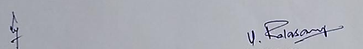

**SIGNATURE SIGNATURE**

Dr K Premalatha Mr. Balasamy K

**Head of the Department Assistant Professor**

Computer Science and Engineering Artificial Intelligence and Data Science

Bannari Amman Institute of Technology Bannari Amman Institute of Technology

Sathyamangalam Sathyamangalam

Erode- 638402 Erode - 638402

**Submitted for Project Viva Voce examination held on**

**Internal Examiner 1 Internal Examiner 2**

**DECLARATION**

We affirm that the project work titled **“SMART ATTENDANCE SYSTEM”** being submitted in partial fulfilment for the award of the degree of **Bachelor of Engineering** in **‘Computer Science and Engineering** is the record of original work done by us under the guidance of **Mr. BALASAMY K** AP/AIDS. It has not formed a part of any other project work(s) submitted for the award of any degree or diploma, either in this or any other University.

 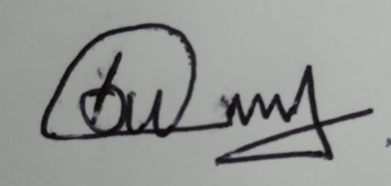 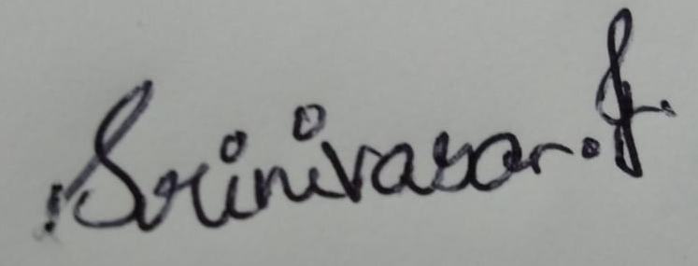

**DHANUSH S SUJEET C SRINIVASAN J**

**(191CS156) (191CS310) (191CS299)**

## **ACKNOWLEDGEMENT**

WE would like to enunciate heartfelt thanks to our esteemed Chairman **Dr.**

**S. V. Balasubramaniam**, Trustee **Dr. M. P. Vijayakumar**, and the respected Principal **Dr. C. Palanisamy** for providing excellent facilities and support during the course of study in this institute.

We are grateful to **Dr K Premalatha**, **Head of the Department [CSE]**

for his / her valuable suggestions to carry out the project work successfully.

We wish to express our sincere thanks to Faculty guide **Mr. Balasamy K, Assistant Professor [AIDS]** for his/ her constructive ideas, inspirations, encouragement, excellent guidance and much needed technical support extended to complete our project work.

We would like to thank our friends, faculty and non-teaching staff who have directly and indirectly contributed to the success of this project.

**DHANUSH S**

**SUJEET C**

**SRINIVASAN J**

## **ABSTRACT**

In the present academic system, regular class atten-cotillion of scholars ’ plays a significant part in performance assessment and quality monitoring. The conventional styles rehearsed in utmost of the institutions are by calling names or subscribing on papers, which is largely time- consuming and insecure. This composition presents the automatic attendance operation system for convenience or data trustability. The system is developed by the integration of ubiquitous factors to make a movable device for managing the scholars’ attendance using Face Recognition technology

**Keywords:***Tkinder, MTCNN, Classification.*

|  |  |  |
| --- | --- | --- |
| **TABLE OF CONTENTS** | | |
| **CHAPTER No.** | **TITLE** | **PAGE No** |
|  | **ACKNOWLEDGEMENT** | **VI** |
|  | **ABSTRACT** | **V** |
| 1 | **INTRODUCTION** |  |
|  | 1.1 EXPLORATION OF AI |  |
|  | 1.2 DATA MANIPULATION | 2 |
| 2 | **LITERATURE REVIEW** | 3 |
| 3 | **PREREQUISITE** | 4 |
|  | 3.1 Cloud and Data Growth | 4 |
|  | 3.2 Feature Engineering Techniques: | 5 |
|  | 3.2.1 Forecasting | 5 |
|  | 3.2.2 Prediction | 6 |
|  | 3.2.3 Data Scraping | 6 |
| 4 | **PROPOSED WORK** | 9 |
|  | 4.1 Face Detection | 11 |
|  | 4.2 Face Cropping | 11 |
|  | 4.3 Feature Extraction | 12 |
| 5 | **USER INTERFACE** | 16 |
| 6 | **RESULTS AND CONCLUSION** | 18 |
|  | **REFERENCE** | 19 |
|  | **ORIGINALITY SCORE** | 20 |

## **CHAPTER -1**

## **INTRODUCTION**

Students’ attendance in the classroom is veritably important task and if taken manually wastes a lot of time. There are numerous automatic styles available for this purpose i.e. biometric attendance. All these styles also waste time because scholars have to make a line to touch their thumb on the scanning device. This work describes the effective algorithm that automatically marks the attendance without mortal intervention. This attendance is recorded by using a camera attached in front of the classroom that's continuously landing images of scholars, descry the faces in images and compare the detected faces with the database and mark the attendance. The paper reviews the affiliated work in the field of attendance system also describes the system armature, software algorithm and results

## **Exploration of AI**

Artificial intelligence is universal, and we encounter it nearly on a diurnal base, without us being apprehensive of it. An adding number of technological developments that we use in our everyday lives are grounded on AI, in order to effectively support us. Whether we make a converse request on a website or spark a quick voice hunt via voice adjunct – in both cases, AI is behind it.

The infusion of AI techniques into so many areas of computing is changing compute paradigms across the board.It is important because it forms the very foundation of computer learning. Through AI, computers have the capability to harness massive quantities of data and use their learned intelligence to make optimal opinions and discoveries in fragments of the time that it would take humans.

**1.2 Data Manipulation**

Data manipulation( DataPre-Processing), a element of data medication, describes any type of processing performed on raw data to prepare it for another data processing procedure. It has traditionally been an important primary step for the data mining process.

More lately, data preprocessing ways have been acclimated for training machine literacy models and AI models and for running consequences against them. The way used in data preprocessing include the following are Data profiling, Data sanctification, Data reduction, Data metamorphosis, Data enrichment and Data confirmation.

It's a step in the data mining and data analysis process that takes raw data and transforms it into a format that can be understood and anatomized by computers and machine

Machines like to reuse nice and tidy information – they read data as s and 0s. So calculating structured data, like whole figures and probabilities is easy. still, unshaped data, in the form of textbook and images must first be gutted and formatted before analysis.

The above mentioned 6 way involve base statistics and data engineering ways like slice, probability, central tendency styles, thesis testing, binning and numerous other principles

## **CHAPTER 2**

## **LITERATURE REVIEW**

Shraddh Arya and Arpit Agarwal( ) proposed a work to design and apply a face recognition system that accepts full or partial face image to corroborate the face of the person. The way involved arepre-processing, LDA algorithm and Neural network. Pre-processing of the images takes place where the image of the face is partitioned to numerous different facial corridor. Secondly LDA algorithm is proposed which features in reducing the dimensional spaces with the reduction of advanced dimensional image to lower dimensional image and retains as important as information possible for recognition. Eventually, a neural network is proposed to train the uprooted features in the database and the trained model receives the input image and computes the input faces and face recognition is performed( 8)Prashant Ksambe,

Akash Upadhyay, Anushka Waingankar, Nevil Pooniwala, Ruchi Shah( 2) proposed a smartphone attendance system which is grounded on mobile operation where face recognition fashion grounded on machine literacy is used to mark the attendance. The result shows the capability of the system to manage with the change in posing and protuberance of faces.

From face recognition with deep literacy, it has been determined that during face discovery, the problem of illumination is answered as the original image is turned into a overeater representation that captures the major features of the image anyhow of image brilliance. In the face recognition system, original facial milestones are considered for farther processing. After which faces are decoded which generates 28 measures of the captured face and the optimal face recognition is done by chancing the person’s name from the encoding.

The authors have claimed to have an delicacy of 98.3%. Shama S, Karthikeyan Shanmugasundaram, Satees Kumar Ramasamy( 3) proposed a deep literacy CNN grounded face recognition system. This model uses MTCNN( Multi-Task Convolutional Neural Network) library for the face alignment, face recognition and FAREC has been enforced using the C language by computer vision. They've enforced Convolutional neural networks on trained point models. They've bandied how CNN and MTCNN( Multi-Task Convolutional Neural Network) helps in facial recognition. The input images are compared with the images in the database and the compared models have maximum delicacy. The false acceptance rate( FAR) is only0. and has delicacy of 96%.

**CHAPTER 3**

**PREREQUISITE**

**3.1 Cloud and Data Growth**

Increased demand for cloud computing, as well as growth connected with artificial intelligence and cognitive computing, are major machine learning as service industry growth drivers. Many open-source and proprietary machine-learning systems support the types of predictions However, the cost of these systems, in terms of hardware and software, was until recently out of reach for most enterprises. Moreover, even if a business could afford it, it typically did not have the machine-learning talent required to design the prediction models or deal with the data science required.

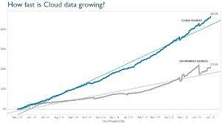

**Figure 3.1 Cloud and Data Growth**

Enter Pall- grounded machine- learning results from the big three public pall providers Google, AWS, and Microsoft. They're veritably different from each other but partake some congruity, advantages, and limitations. The internet companies were the first to apply machine learning to huge amounts of data, which is why technologies like MapReduce and BigTable were invented at places like Google, but we're seeing the same techniques move into every other application area: genetics , health , energy, finance, security, and even the army. It's pervasive enough that "Big Data" conferences like Strata have thousands of attendees.The reason machine learning works today is not due to any algorithmic breakthrough, but a decades-long macro-trend to digitize and network data, which is just now bearing fruit.

**3.2 Feature Engineering Techniques:**

Feature Engineering Techniqueis a logical grouping of items of interest to the organization, or areas of interest within the organization**.** The rule for determining the sphere boundary may be as simple as a data type with an enumerated list of values.

**3.2.1 Forecasting**

ML forecasting algorithms frequently use ways that involve more complex features and prophetic styles, but the ideal of ML soothsaying styles is the same as that of traditional styles – to ameliorate the delicacy of vaticinations while minimizing a loss function. The loss function is generally taken as the sum of places due to crimes in vaticination/forecasting.

There are four methods of forecasting. They are,

* Straight-line.
* Moving average.
* Simple linear regression.
* Multiple linear regression.

There are two types of forecasting methods: qualitative and quantitative. Each type has different uses so it's important to pick the one that that will help you meet your goals.

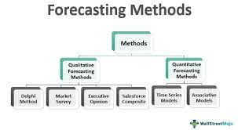

**Figure 3.2 Forecasting Methods**

**3.2.2 Prediction**

“Prediction” refers to the output of an [algorithm](https://www.datarobot.com/wiki/algorithm/) after it has been [trained](https://www.datarobot.com/wiki/training-validation-holdout/) on a historical dataset and applied to new data when forecasting the likelihood of a particular outcome.

The “Prediction” has to do with, for example, whether or not a transaction that already occurred was fraudulent. In that case, the transaction already happened, but you’re making an educated guess about whether or not it was legitimate, allowing you to take the appropriate action**.**

**3.2.3 Data Scraping**

Data scraping is commonly manifest in web scraping, the process of using an application to extract valuable information from a website.It is one of the most efficient ways to get data from the web, and in some cases to channel that data to another website.

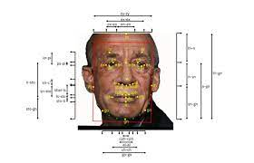

**Figure** **3.3 Data Scraping from image**

There are three main types of data scraping:

* Report mining Programs pull data from websites into stoner- generated reports..
* Screen scraping The tool pulls information on heritage machines into ultramodern performances.

Web scraping Tools pull data from websites into reports druggies cancustomize.data centre is a structure, a devoted space within a structure, or a group of structures used to house computer systems

There are three techincal variants in scarping. They are,

* Screen scraping
* Web scraping
* Report Mining

**CHAPTER -4**

**4. PROPOSED WORK**

Marking attendance in an educational institution is an important task to estimate the overall performance of a pupil. Face recognition system is homemade and hence time consuming. thus, it's demanded to make an automated system which marks the attendance of the scholars with lower trouble as possible. The proposed model aims to achieve the below by erecting a smart attendance system depicted in the figure below

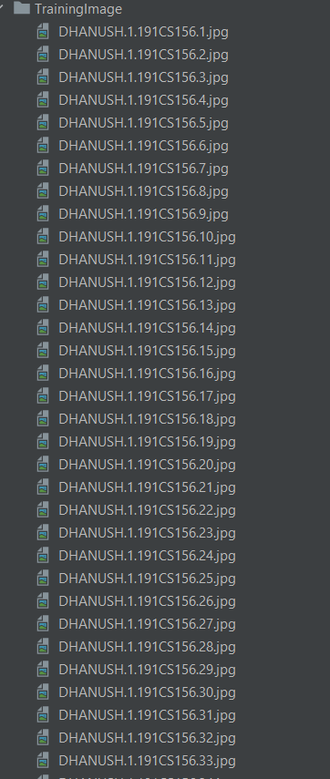

**Figure** **4.1 Images of students**

The photo of the student’s inside the classroom will be taken by the lecturers. Depending on the dimension of the class we take multiple photos to cover all the students in the class without missing any one of them. Face recognition is performed using MTCNN(Multi-Task Convolutional Neural Network) and finally gets the list of all the students who are present in that photo and is updated in the form of a text file. Process:

1. Camera section This section consists of the Camera that's used to take the image of the scholars present in the classroom. The Camera must be installed in every classroom to take the image.

2. Train and Test section This section consists of a laptop or a desktop computer in which a smart attendance system programwill be running. The program will do training and testing for any new image uploaded from the camera.

3. Compute Section his section consists of three modules like database for storing and reacquiring the data, Face recognition module is used to fete the face using the data in database and Attendance update is used to modernize the attendance in the attendance distance

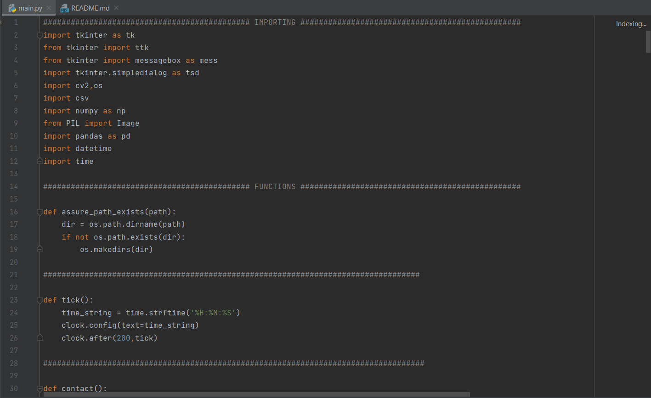

**Figure** **4.2 Libraries Used**

Face recognition system MTCNN( Multi-Task Convolutional Neural Network) provides an effective fashion for face recognition grounded on the Convolutional neural network. It gives ideas about the styles involved in face recognition step by step. It consists of four main way, they're Face Discovery, Face Alignment, Face cropping and point birth. Face recognition system Shows the overview of the MTCNN(Multi-Task Convolutional Neural Network) Face recognition system that starts from the input image of a person to be recognized, then detects the landmark of the alignment will be done. Later the features are extracted from facial images.

**4.1 Face Detection**

The face discovery is a computer vision technology to descry the frontal faces of the person from the digital image or videotape. This will descry the anterior faces by using facial corner discovery of upper lips and nose. mortal nose is the middle point of the facial milestones. The precise discovery of mortal faces is a much more important process. MTCNN( MultiTask Convolutional Neural Network) facial corner sensor which is briskly, more effective and lower than the original interpretation. a 5point facial corner sensor is used. The 68- point sensor localizes regions along eyes, nose, mouth, jawline and eyebrows. The 5- point facial corner discovery reduces this information.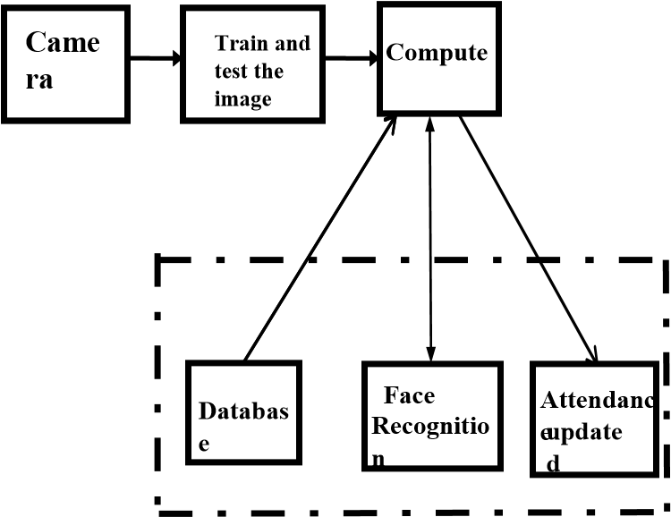

**Figure** **4.3 Block Diagram**

**4.2 Face Cropping**

Face cropping is the process of elimination of unasked external area from an image. Face cropping is used to learn the facial features of humans in neural networks. The process encompasses in omission of gratuitous trash from the image, to ameliorate its architecture or separate the subject matter from its background.

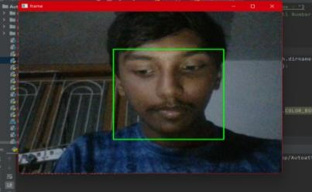

**Figure** **4.4 Face Cropping**

**4.3 Feature Extraction**

When it comes to Machine Learning, Artificial Neural Networks perform very well. Artificial Neural Networks is used in various classification tasks to classify image, audio, words etc. Convolutional neural network is a derivative of ANN which is used mainly to classify images like classification of images of animals, plants or face recognition. Convolutional neural network is designed to process data through multiple layers of arrays.

The primary difference between Convolutional neural network and any other ordinary neural network is that Convolutional neural network takes input as a two-dimensional array and operates directly on the images rather than focusing on feature extraction. The solution for the problems in face recognition can be solved using Convolutional neural network approach. A convolutional neural network uses three basic ideas:

(a) Local respective fields

(b) Convolution

(c) Pooling

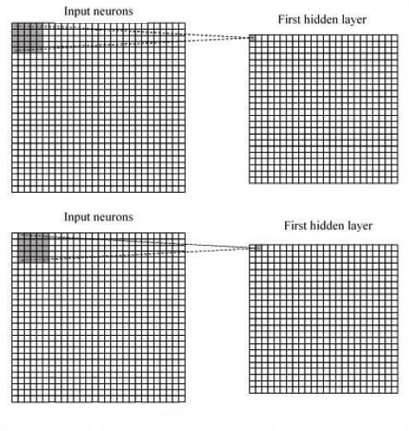

**Figure** **4.5 Layers of Algorithm**

CNN uses spatial correlations which are present in the input data. Each layer of a neural network is connected to some of the input neurons. This region is called the local respective field. Local respective field is used to mainly focus on the hidden neuron.

The output from the pooling layer is provided to the fully connected layer which is a regular neural network layer that gets input data from the last layer and computes the class scores and provides the -D array of size which is the same as the number of classes.

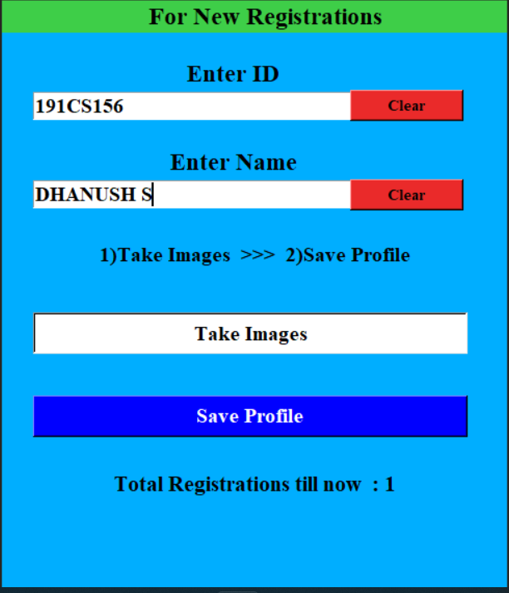

**Figure** **4.6 New Registration Form GUI**

**Database**

A database is an systematized collection of data, generally stored and penetrated internally from a computer system. Formally, a" database" refers to a set of affiliated data and the way it's organized. Access to this data is generally handed by a database operation system conforming of an integrated set of computer software that allows druggies to interact with one or further databases and provides access to all of the data contained in the database. The DBMS provides colorful functions which allows entry, storehouse and reclamation of large amounts of information and provides ways to manage how that information is organized. In this proposed work Database consists of 00 images and the database path is given to the program to compare the faces with test images.

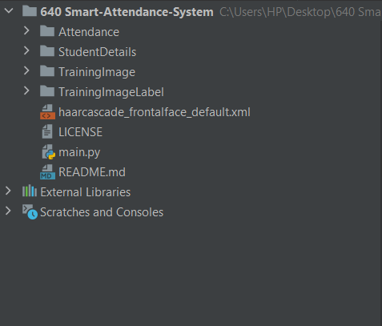

**Figure** **4.7 File Structure**

**CHAPTER- 5**

**5. USER INTERFACE**

**5.1 User Interface**

In this Attendance System the Attendance for students is marked using Face verification. Create account by registering as a user faculty and Login to account. After Login the faculty has the access to add a student, take Attendance, modify Student details. The faculty can search

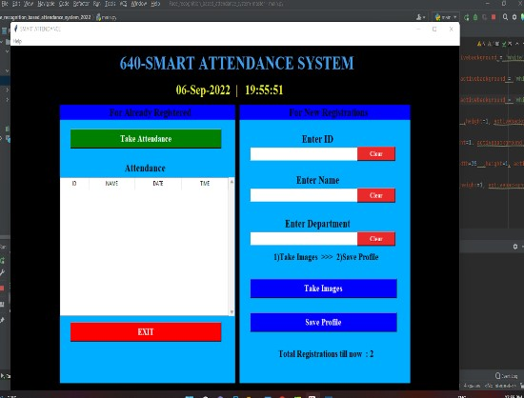

**Figure** **5.1 User Interface of Smart Attendance**

Attendance of a pupil using Multiparameter Search, by specifying the pupil ID, date of attendance, period of Attendance. The credentials for the faculty are handed by superuser who has access to the whole database. Differently we can produce faculty as a stoner through register signup and also login to the main account. In this system you can register as a stoner faculty through signup and using social account google or Facebook.

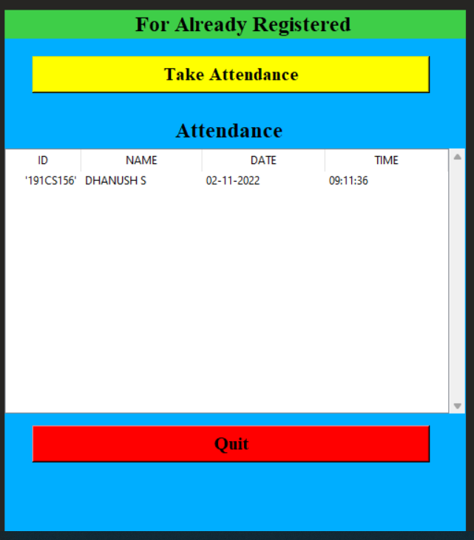

**Figure** **5.2 After taking Attendance**

Through google and Facebook social account, this web app only creates user, The credentials for the Faculty are provided by the superuser who has access to the whole database. Only the superuser can create faculty . We can add multiple faculty in user through superuser.

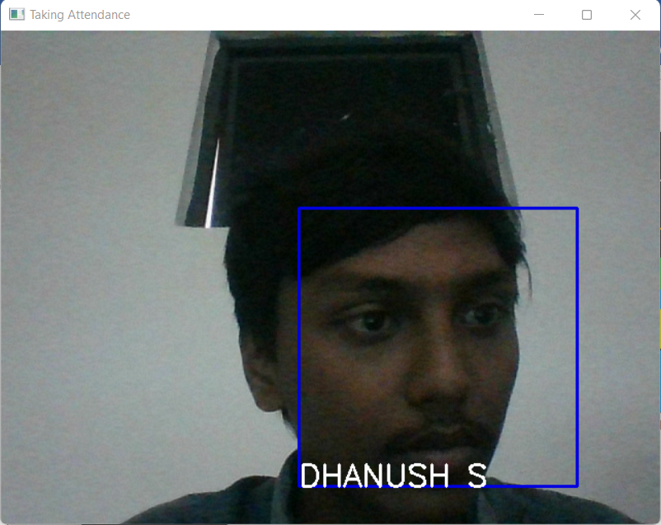

**Figure** **5.3 Recognition of Student Face**

**CHAPTER- 6**

**6. RESULTS AND CONCLUSION**

The dataset of the proposed work consists of 100 images. The group image which is downloaded from the link will be compared with the dataset one after the other. However, also it marks as present and gets streamlined in the txt train, If both the faces are matched. The proposed work is tested on two group images. Out of 100 people in the test dataset, we took a print of a group of three. The image in has three scholars.

In this work, a smart attendance system has been proposed. The proposed work is devoted to design and apply a face recognition model that accepts face images in order to fete the face and it facilitates to modernize the attendance of the scholars in a veritably effective manner. The proposed model for taking attendance is effective in reducing redundant tackle factors needed to take attendance. All the bias needed for this purpose are formerly available with nearly everyone in the present day and age. MTCNN(Multi-Task Convolutional Neural Network) Face recognition approach for detecting and feting faces has been seen to be veritably effective. Hence from the below results we can gain a paperless attendance system which is automatically maintained. This system effectively reduces deputy for the scholars and also is a time effective system.

**REFERENCES**

1. “Face Recognition with Partial Face Recognition and Convolutional Neural Network” Shraddha Arya and Arpit Agarwal, International Journal of Advanced Research in computer Engineering Technology, Jan 20 8.
2. “Face Recognition based Attendance Management System using Machine Learning” Anushka Waingankar, Akash Upadhyay, Ruchi Shah, Nevil Pooniwala and Prashant Kasambe,International Research Journal of Engineering and Technology(IRJET), 20 8.
3. “FAREC-CNN Based Efficient Face Recognition Technique using MTCNN(Multi-Task Convolutional Neural Network)” Sharma S, Karthikeyan Shanmugasundaram, Satees Kumar Ramasamy, International Conference on Advanced Communication Control and Computing Technologies (ICACCCT),20 6.
4. Smart Attendance Management System” Sanjay Badhe, Kunal Chaudhari, Sneha Kale, Tejaswi Mane, International Journal of Computer Applications National Conference on Advancements in Computer & Information Technology (NCACIT), 20 6.
5. “Attendance System Using a Mobile Device: Face Recognition, GPS or Both?” Geetha Baskaran, Ahmad Farhan Aznan, International Journal of Advances in Electronics and Computer Science, Volume– 3, Issue–8, pp. 26–32, 20 *6.*

